Troubleshooting - Online Registration and Logging In

Registration - Trade Account Page
Gallery Direct is a trade-only supplier, therefore all users are required to register and be approved before viewing our pricing and stock availability, as well as gaining access to our complete online account management tools.

When using the website for the first time, you will need to either register as an ‘Existing Trade Customers’ or a ‘New Trade Application’:

EXISTING TRADE CUSTOMERS
If you are an existing customer then please register using your Gallery Account Number, which is the 5 digit number prefixed with ‘C’, this will speed up the registration process and you will not need to complete our full Account Opening Form again.

NEW TRADE APPLICATION
If you do not currently have an account with us, we will need you to complete our Trade Account Form and once your registration has been verified you will receive an email confirming your access.
Please note – your account will not be officially opened with Gallery Direct until your first order is submitted.

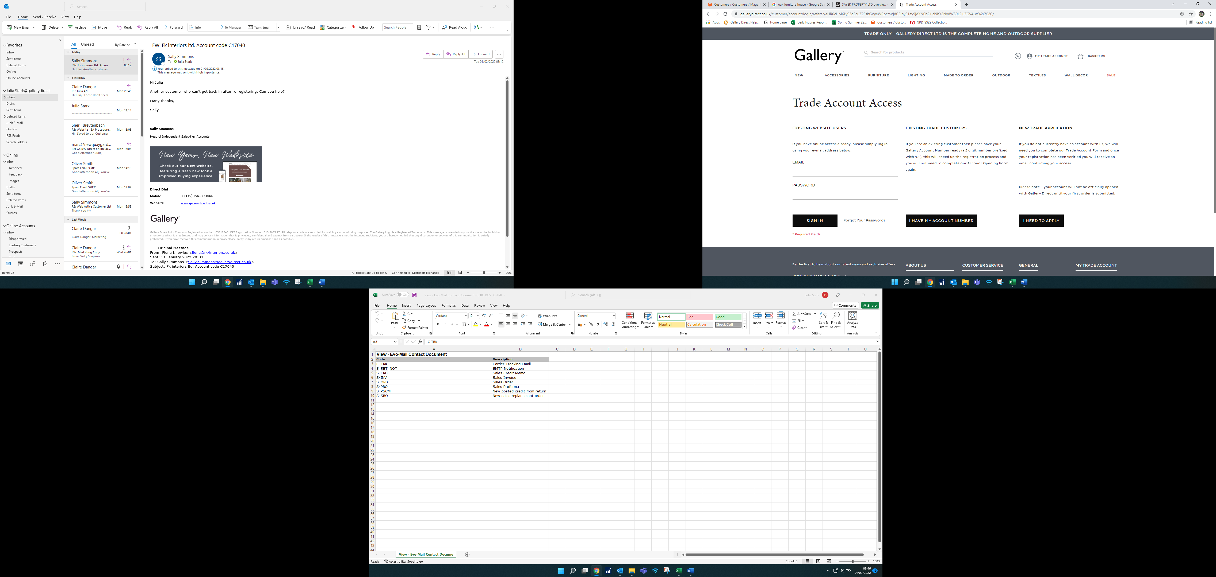

How will I know if I have been approved?
Once approved an e-mail confirmation will be sent to notify you that you can now log in.
Please ensure you have checked your junk or spam folders for this notification e-mail
The email and password created when registering are now the details to be entered on the Trade Account Access page in the EXISTING WEBSITE USERS section.
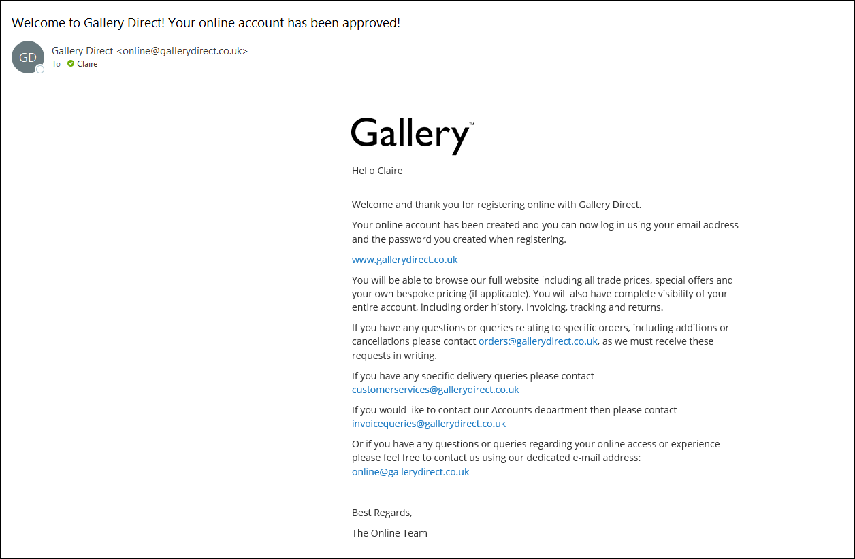

What happens if I have been denied online access?
An e-mail notification will be sent informing you of the decision to deny access. If you feel this decision has been made in error then we welcome you to appeal with supporting evidence of your business trading – as per the example e-mail below.

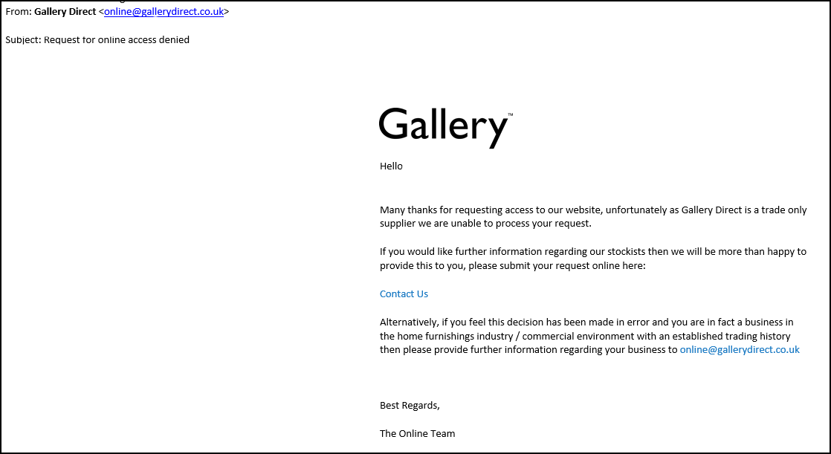

Alternatively, if you are indeed not a business within the required industry then we do also welcome a one-off ‘Cash & Carry sales, if you are still a business – for example, if you are a hairdresser, electrician etc.
Simply go to our Sales Team page and contact the salesperson in your local area. Please provide them with the items you would like to order and they will quote and process the order as a one-off sale.
You would still not been granted access to our online store on a Cash & Carry basis.

Troubleshooting - Error Messages when Logging In
- The e-mail address entered has not been registered – please register as either an Existing Trade Customer or a New Trade Application using the applicable links below
This error means that the e-mail entered has not yet been registered to gain access to the site.
Please register using the applicable form and await approval (usually granted within 24-48 hours of registration, excluding weekends and Bank Holidays)

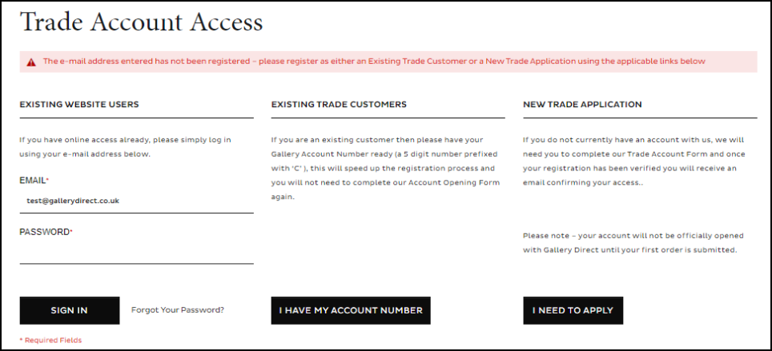

- Your account is pending approval
Please allow 24-48 hours for your request to be approved (excluding weekends and bank holidays).
If this time has elapsed and you have not received an e-mail regarding approval or disproval, then please contact online@gallerydirect.co.uk
Please ensure you have checked your junk or spam folders for this notification e-mail
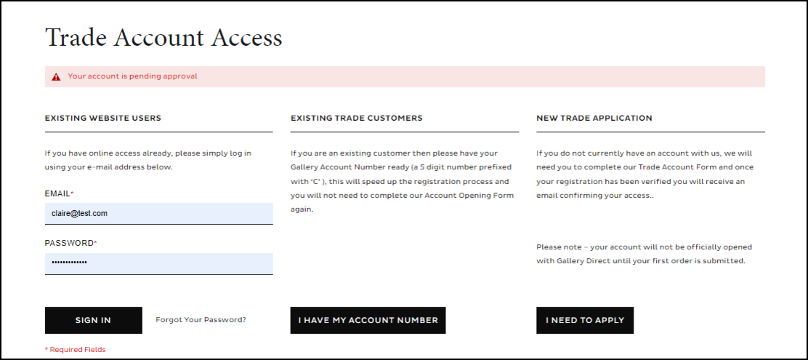

- The account sign in was incorrect. Please check and try and again, alternatively please use the "Forgot your password" link below
You have entered an incorrect password for an already registered e-mail address. Please ensure you enter the correct password or alternatively use the ‘Forgotten Password link’
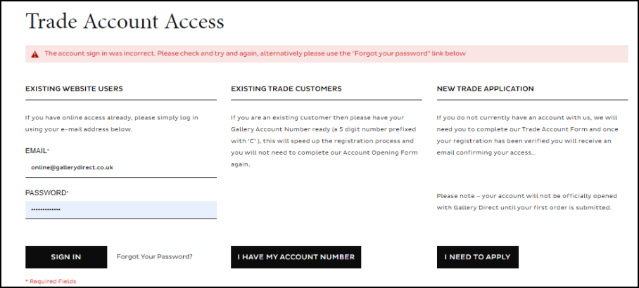

How do I reset my online password?
Please use the Forgotten password link on our log in page here
If you are still experiencing issues then please e-mail online@gallerydirect.co.uk, alternatively please call our Head Office on 01795 439159.

